**Polynomial Regression**

* Polynomial Regression is a regression algorithm that models the relationship between a dependent(y) and independent variable(x) as nth degree polynomial.
* The Polynomial Regression equation is given: y= b0+b1x1+ b2x12+ b2x13+...... bnx1n
* It is also called the special case of Multiple Linear Regression in ML. Because we add some polynomial terms to the Multiple Linear regression equation to convert it into Polynomial Regression.
* It is a linear model with some modification in order to increase the accuracy.
* The dataset used in Polynomial regression for training is of non-linear nature.
* It makes use of a linear regression model to fit the complicated and non-linear functions and datasets.

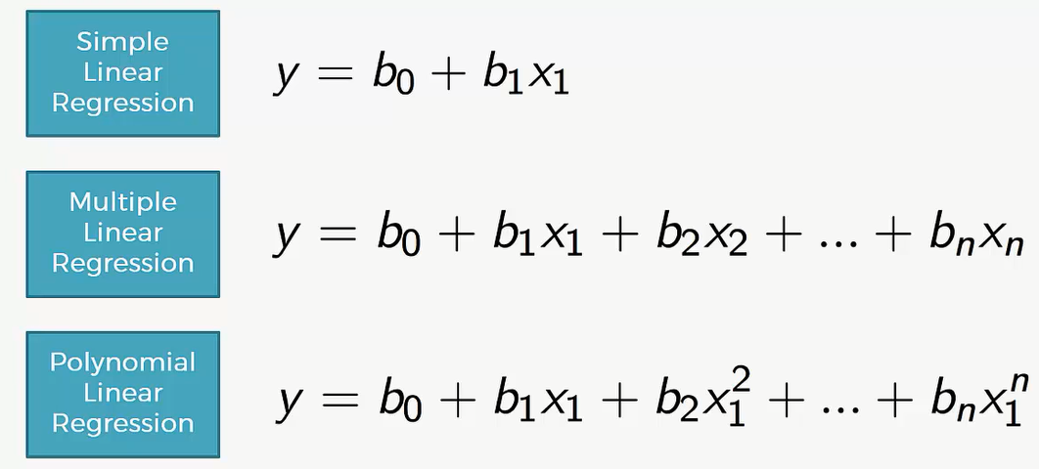

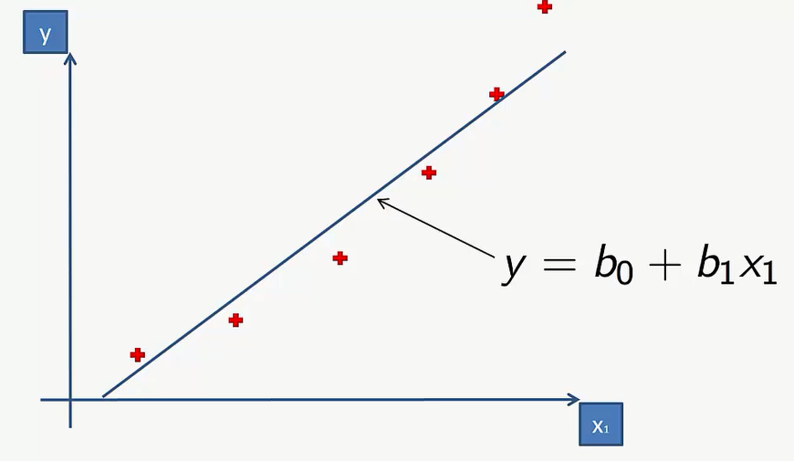

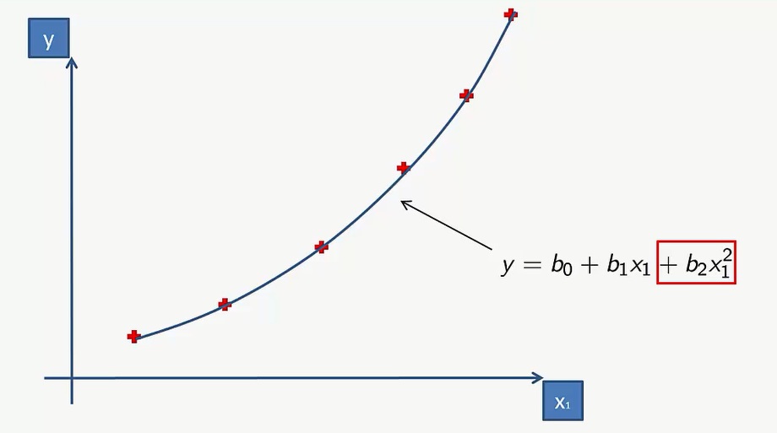

* In the above image, we have taken a dataset which is arranged non-linearly. So if we try to cover it with a linear model, then we can clearly see that it hardly covers any data point. On the other hand, a curve is suitable to cover most of the data points, which is of the Polynomial model.
* Final equation….

